**SPRINT-3**

**IoT Device – Watson communication**

The data from IoT device should reach IBM Cloud

(The data stored in IBM Cloud should be properly integrated with Cloudant DB)

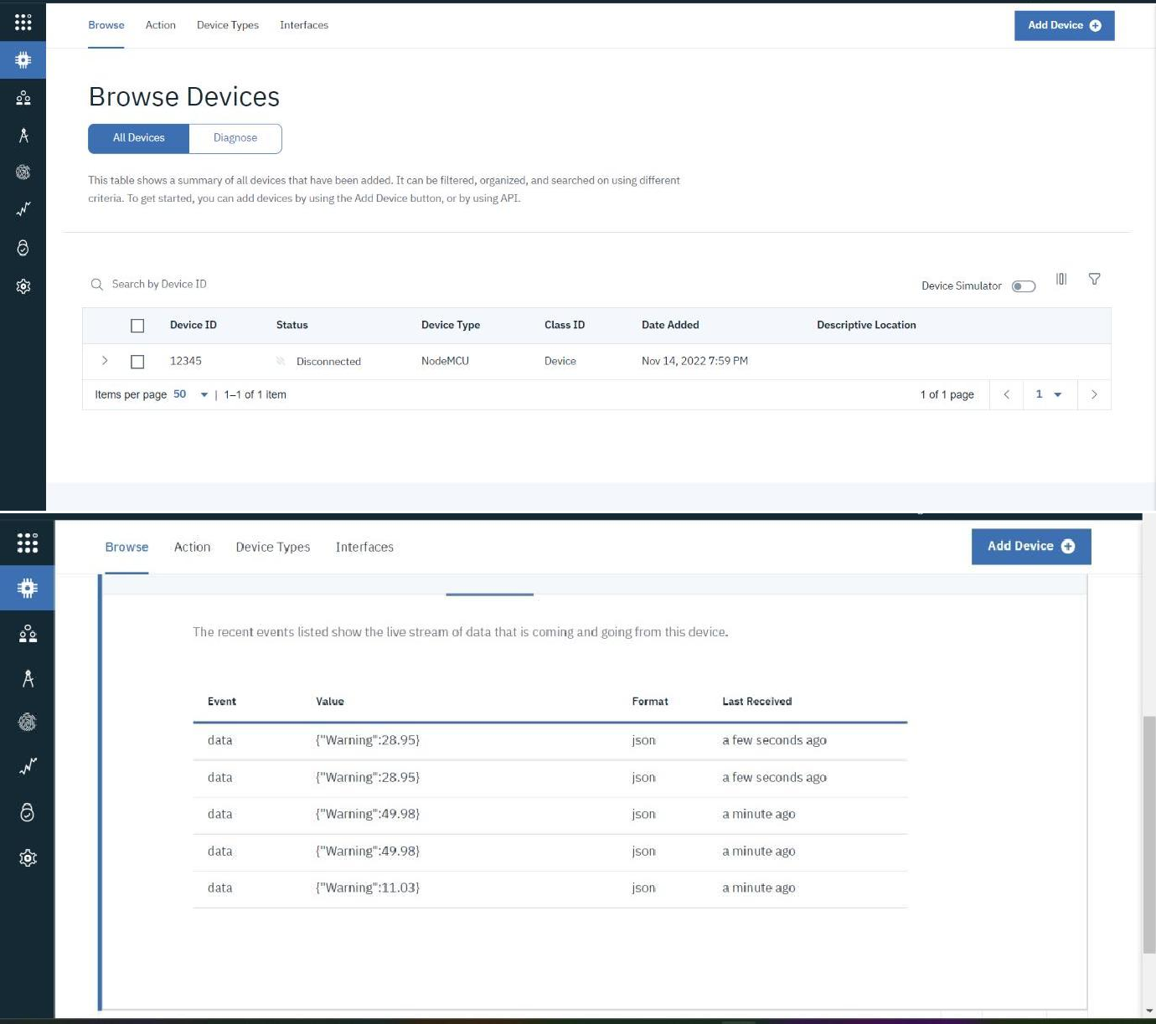

NODE RED-CLOUDANTDB COMMUNICATION:

